The Role of NRF2 Signaling in Low Grade Chronic Inflammation

COST Action CA20121 Working Group 3

A long and healthy life benefits from the absence of exposure to detrimental triggers such as stress, environmental factors (poor diet and physical inactivity), and/or genetic and epigenetic alterations. These cause profound metabolic dysregulation that alter physiological processes, such as vascular function, immune responses, and cellular signaling all leading to the development of chronic non-communicable diseases (NCD). However, chronic exposure to these harmful drivers of disease, in combination with genetic predisposition, can lead to NCD and accelerated ageing. Long term low grade systemic inflammation (LGI) is the most significant underlying hallmark of these altered metabolic processes. Therefore, early detection of LGI is of the upmost importance to find high-risk populations for NCD development, to target for pharmacological or non-pharmacological treatment.
NCDs share a high degree of connectivity at the pathophysiological level, with common signs of chronic low-grade inflammation, oxidative stress, and metabolic disturbances. Within this connectivity network, the transcription factor NRF2 (nuclear factor (erythroid-derived 2)-like 2) plays a cardinal regulatory role, and impairment of its homeostatic functions is associated with metabolic dysfunctions (fatty acid, amino acid, and glucose metabolism), impaired autophagy-lysosomal pathway, and chronic low-grade inflammation, which in concert contribute to progression of NCDs (Figure 1).
Pathological formation of reactive oxygen and nitrogen species (ROS and RNS, respectively) stimulate and aggravate inflammatory conditions at various levels (Wenzel et al., 2017), including persistent activation of nuclear factor κB (NF-κB), NLRP3 inflammasome, high-mobility group box 1 (HMGB1) and Neutrophil Extracellular Traps (Abais et al., 2015; Lood et al., 2016; Schauer et al., 2014). These observations suggest the existence of a tight correlation between redox homeostasis and control of inflammation. As an intracellular integrator and also regulator of many of the extracellular inflammatory signal, the NRF2 pathway, along with the members of its signaling pathway (the Keap1/NRF2 system), has recently been acknowledged as one of the major anti-inflammatory and anti-oxidant mechanisms through life (Figure 1). All these studies point to NRF2 as a brake in the inflammatory process, which is crucial to avoid exacerbated or persistent inflammation.
Activators of NRF2 signaling have shown convincing pre-clinical benefits. This link has been strongly supported by data from Nrf2-knock-out mice, in which the role for NRF2 has been shown in the connectivity networks of LGI. In addition, there are genetic associations between inflammation and functional polymorphisms in the NRF2 gene. This rapidly increasing knowledge, coming from genetics and preclinical studies in the NRF2 field will result in novel strategies for pharmaceutical and -non-pharmaceutical interventions in diseases associated by LGI, oxidative stress and key metabolic alterations: the major targets of NRF2.
Lifestyle interventions which are based on a balanced diet and an adequate amount of physical activity are considered one of the most successful strategies for restoring metabolic health. Therefore, nutritional interventions may be successful in controlling LGI and NRF2 derangements. Considering the above observations, any intervention that extends the lifespan, but also the health span of any individual will counteract risk factors involved in LGI and the onset of pathologies which are linked to ageing related conditions.
A better understanding and early detection of the onset of chronic low-grade inflammation-driven NCDs and identification of quantifiable markers able to predict an imminent transition from health state and conversion to early disease state across the lifespan are imperative for the development of effective preventive and more successful treatment strategies with the ultimate goal of reducing morbidity and mortality.
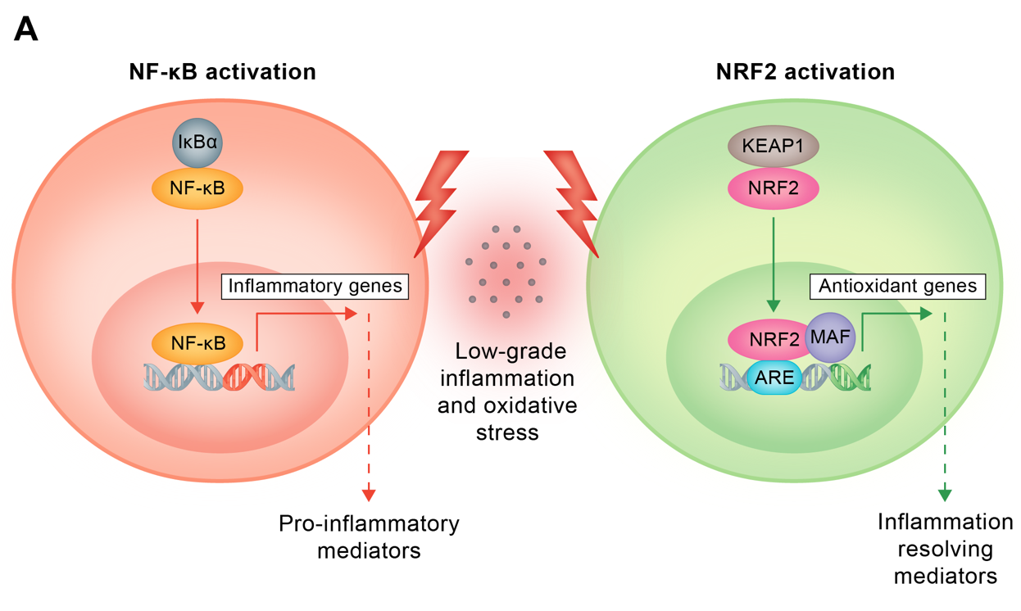
Figure 1. NRF2 signaling in redox homeostasis. Persistent activation of NF-κB leads to the expression and build-up of inflammatory mediators contributing to low-grade inflammation and oxidative stress. These mediators in turn trigger the activation of the NRF2 signaling pathway and subsequent antioxidant messengers, thereby eliciting homeostatic control and counteracting detrimental effects of LGI.

References
Abais, J. M., Xia, M., Zhang, Y., Boini, K. M., & Li, P.-L. (2015). Redox Regulation of NLRP3 Inflammasomes: ROS as Trigger or Effector? Antioxidants & Redox Signaling, 22(13), 1111–1129. https://doi.org/10.1089/ars.2014.5994
Lood, C., Blanco, L. P., Purmalek, M. M., Carmona-Rivera, C., De Ravin, S. S., Smith, C. K., Malech, H. L., Ledbetter, J. A., Elkon, K. B., & Kaplan, M. J. (2016). Neutrophil extracellular traps enriched in oxidized mitochondrial DNA are interferogenic and contribute to lupus-like disease. Nature Medicine, 22(2), 146–153. https://doi.org/10.1038/nm.4027
Schauer, C., Janko, C., Munoz, L. E., Zhao, Y., Kienhöfer, D., Frey, B., Lell, M., Manger, B., Rech, J., Naschberger, E., Holmdahl, R., Krenn, V., Harrer, T., Jeremic, I., Bilyy, R., Schett, G., Hoffmann, M., & Herrmann, M. (2014). Aggregated neutrophil extracellular traps limit inflammation by degrading cytokines and chemokines. Nature Medicine, 20(5), 511–517. https://doi.org/10.1038/nm.3547
Wenzel, S. E., Tyurina, Y. Y., Zhao, J., Croix, C. M. S., Dar, H. H., Mao, G., Tyurin, V. A., Anthonymuthu, T. S., Kapralov, A. A., Amoscato, A. A., Mikulska-Ruminska, K., Shrivastava, I. H., Kenny, E. M., Yang, Q., Rosenbaum, J. C., Sparvero, L. J., Emlet, D. R., Wen, X., Minami, Y., … Kagan, V. E. (2017). PEBP1 Wardens Ferroptosis by Enabling Lipoxygenase Generation of Lipid Death Signals. Cell, 171(3), 628-641.e26. https://doi.org/10.1016/j.cell.2017.09.044

